# SKILLS

* **Java**

GAVANDE RUSHIKESH RAMDAS

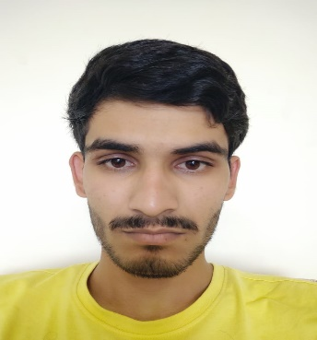[rushikesh.gavande10@gmail.com](mailto:rushikesh.gavande10@gmail.com) | (+91) 8767991300

 https:/[/www.linkedin.com/in/rushikesh-gavande-535154202](http://www.linkedin.com/in/rushikesh-gavande-535154202)

# HTML, CSS

* + **MySQL**
  + **Spring Boot**

# EDUCATION

* **MASTERS IN COMPUTER SCIENCE(pursuing) CGPA: 8.5(FYMSC)| (2023-2025)**

DR.D.Y.PATIL ARTS COMMERCE AND SCIENCE COLLEGE PIMPRI

# BACHLOR OF COMPUTER SCIENCE CGPA:8.85/10|(2020-2023)

SANGAMNERCOLLEGE,SANGAMNER.

# XII 74.46%| 2020

HANDE DESHMUKH SCHOOL AND JR. COLLEGE ,ALEPHATA.

**EXPERIENCE- none**

# ACADEMIC PROJECTS

* **JOBPORTAL USING SPRING BOOT**

build REST APIs for a Job Portal Management System Project using Spring Boot, Spring Data JPA (Hibernate), and MySQL database.

# HOTEL MANAGEMENT SYSTEM

* + Developed a user-friendly interface using HTML and CSS within the CodeIgniter-4 framework, enabling
  + Users to book, view, and manage their hotel room reservations.

# ELECTRONICS SHOP

* e-commerce website using wordpress

# ACHIEVEMENTS / HOBBIES

* **Camping.**
* **Traveling.**
* **Running.**
* **Enthusiast in health and fitness.**